**1. Create a Spring Web Project using Maven**

**Pom.xml**

<project xmlns="http://maven.apache.org/POM/4.0.0"

xmlns:xsi="http://www.w3.org/2001/XMLSchema-instance"

xsi:schemaLocation="

http://maven.apache.org/POM/4.0.0

http://maven.apache.org/xsd/maven-4.0.0.xsd">

<modelVersion>4.0.0</modelVersion>

<groupId>com.cognizant</groupId>

<artifactId>spring-learn</artifactId>

<version>0.0.1-SNAPSHOT</version>

<name>spring-learn</name>

<description>Spring Web Maven Project</description>

<packaging>jar</packaging>

<properties>

<java.version>17</java.version> <!-- Or use 21/11 based on your JDK -->

</properties>

<dependencyManagement>

<dependencies>

<dependency>

<groupId>org.springframework.boot</groupId>

<artifactId>spring-boot-dependencies</artifactId>

<version>3.2.4</version>

<type>pom</type>

<scope>import</scope>

</dependency>

</dependencies>

</dependencyManagement>

<dependencies>

<!-- Spring Web -->

<dependency>

<groupId>org.springframework.boot</groupId>

<artifactId>spring-boot-starter-web</artifactId>

</dependency>

<!-- Spring Boot DevTools -->

<dependency>

<groupId>org.springframework.boot</groupId>

<artifactId>spring-boot-devtools</artifactId>

<scope>runtime</scope>

<optional>true</optional>

</dependency>

<!-- Spring Boot Test -->

<dependency>

<groupId>org.springframework.boot</groupId>

<artifactId>spring-boot-starter-test</artifactId>

<scope>test</scope>

</dependency>

</dependencies>

<build>

<plugins>

<!-- Spring Boot Maven Plugin -->

<plugin>

<groupId>org.springframework.boot</groupId>

<artifactId>spring-boot-maven-plugin</artifactId>

<version>3.2.4</version>

<executions>

<execution>

<goals>

<goal>repackage</goal>

</goals>

</execution>

</executions>

</plugin>

</plugins>

</build>

</project>

**SpringLearnApplication.java**

package com.cognizant.springlearn;

import org.springframework.boot.SpringApplication;

import org.springframework.boot.autoconfigure.SpringBootApplication;

import org.slf4j.Logger;

import org.slf4j.LoggerFactory;

@SpringBootApplication

public class SpringLearnApplication {

private static final Logger LOGGER = LoggerFactory.getLogger(SpringLearnApplication.class);

public static void main(String[] args) {

SpringApplication.run(SpringLearnApplication.class, args);

LOGGER.info("Inside main()");

}

}

**Output**

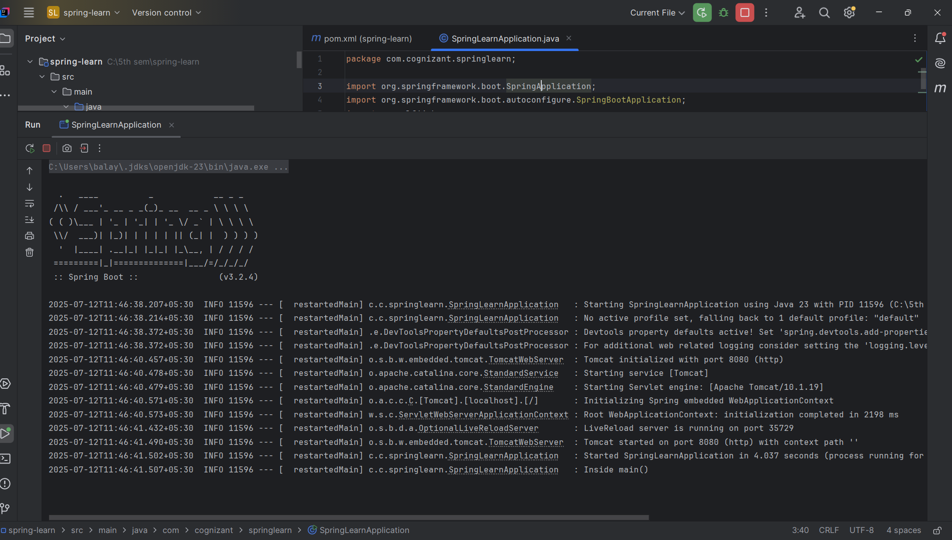

**2. Spring Core – Load SimpleDateFormat from Spring Configuration XML**

**Pom.xml**

<project xmlns="http://maven.apache.org/POM/4.0.0"

xmlns:xsi="http://www.w3.org/2001/XMLSchema-instance"

xsi:schemaLocation="

http://maven.apache.org/POM/4.0.0

http://maven.apache.org/xsd/maven-4.0.0.xsd">

<modelVersion>4.0.0</modelVersion>

<groupId>com.cognizant</groupId>

<artifactId>spring-learn</artifactId>

<version>0.0.1-SNAPSHOT</version>

<name>spring-learn</name>

<description>Spring Web Maven Project</description>

<packaging>jar</packaging>

<properties>

<java.version>17</java.version> <!-- Or use 21/11 based on your JDK -->

</properties>

<dependencyManagement>

<dependencies>

<dependency>

<groupId>org.springframework.boot</groupId>

<artifactId>spring-boot-dependencies</artifactId>

<version>3.2.4</version>

<type>pom</type>

<scope>import</scope>

</dependency>

</dependencies>

</dependencyManagement>

<dependencies>

<!-- Spring Web -->

<dependency>

<groupId>org.springframework.boot</groupId>

<artifactId>spring-boot-starter-web</artifactId>

</dependency>

<!-- Spring Boot DevTools -->

<dependency>

<groupId>org.springframework.boot</groupId>

<artifactId>spring-boot-devtools</artifactId>

<scope>runtime</scope>

<optional>true</optional>

</dependency>

<!-- Spring Boot Test -->

<dependency>

<groupId>org.springframework.boot</groupId>

<artifactId>spring-boot-starter-test</artifactId>

<scope>test</scope>

</dependency>

</dependencies>

<build>

<plugins>

<!-- Spring Boot Maven Plugin -->

<plugin>

<groupId>org.springframework.boot</groupId>

<artifactId>spring-boot-maven-plugin</artifactId>

<version>3.2.4</version>

<executions>

<execution>

<goals>

<goal>repackage</goal>

</goals>

</execution>

</executions>

</plugin>

</plugins>

</build>

</project>

**SpringLearnApplication.java**

package com.cognizant.springlearn;

import org.slf4j.Logger;

import org.slf4j.LoggerFactory;

import org.springframework.boot.SpringApplication;

import org.springframework.boot.autoconfigure.SpringBootApplication;

import org.springframework.context.ApplicationContext;

import org.springframework.context.support.ClassPathXmlApplicationContext;

import java.text.SimpleDateFormat;

import java.util.Date;

@SpringBootApplication

public class SpringLearnApplication {

private static final Logger LOGGER = LoggerFactory.getLogger(SpringLearnApplication.class);

public static void main(String[] args) {

SpringApplication.run(SpringLearnApplication.class, args);

LOGGER.info("Inside main()");

displayDate();

}

public static void displayDate() {

ApplicationContext context = new ClassPathXmlApplicationContext("date-format.xml");

SimpleDateFormat format = context.getBean("dateFormat", SimpleDateFormat.class);

try {

Date date = format.parse("31/12/2018");

System.out.println("Parsed Date: " + date);

} catch (Exception e) {

e.printStackTrace();

}

}

}

**Output**

